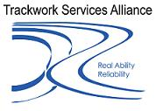
FM005b

ICAM
Investigation Report

Business Unit: Trackwork ServicesAlliance
Date: Monday 27th August 2009
Brief Description of Incident:
Report Prepared By: Keith Breckon
Date of Report 18.09.09

Table of Contents:

Table of Contents: 1
1. Scope of Investigation: 1
2. Investigation Team Members: 1
3. Incident Description & Sequence of Events: 1
5. Incident Risk Assessment 1
6. Contributory Factors 1
6.1 ICAM Summary Chart 1
7. General Conclusions & Key Learning’s 1
8. Recommended Corrective Actions 1
9. Appendix 1: Downer EDI Works Risk Assessment Matrix 1

1. Scope of Investigation:

The scope of this investigation includes an analysis of contributory factors associated with the incident in question. During the course of investigation other relevant findings, which may not have directly contributed to the incident, have also been duly noted.

2. Investigation Team Members:

The following persons were directly engaged in the investigation process:

Name | Position
Keith Breckon  Paul Harvey | Rail Safety OHS Manager Trackwork Services Alliance  Project Engineer Trackwork Services Alliance

3. Incident Description & Sequence of Events:

Excavator on un-even ground Wood used to align excavator
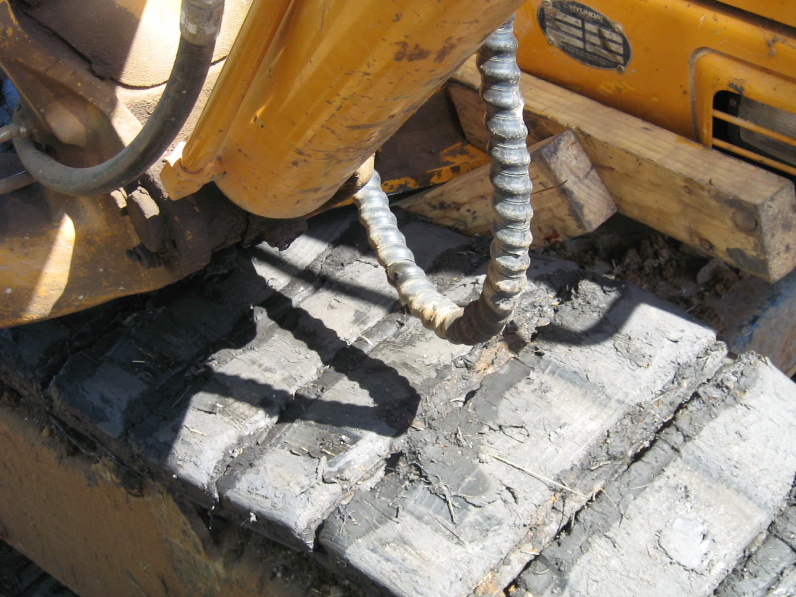
On the Sunday the 09th August 2009 ,at approximately 1500hrs the Work site Protection Officer(WPO) for the Strathfield 536 points reconditioning work site was contacted by the RailCorp Traffic Officer(TO) piloting team 1 tampers for permission to travel through the worksite on the Down Main in accordance with NWT 302 and NPR 700 .
The WPO contacted the Site Superintendant to obtain permission for the tamper to enter the work site and gain an assurance the site was clear of equipment and personnel to allow the machine to proceed. The Site Superintendant gave the authority for the machine to enter which the WPO advised the TO to proceed under caution. The protection officer then went to the Country end of the worksite to set the points for the

The sequence of events before, during and following this incident are described below:
Event Sequence | Date | Approx Time | Event Description:
1 | 15.10.08 | - | Subcontractor was issued a Authority To Work Permit – Contractor signed copy of the permit.
2 | 16.10.08 | - | Contractor starts work on 16.10.08 and received site specific induction
3 | 18.10.08 | - | Contractor re-assessed competent to operate excavator by Workcover assessor
4 | 27.10.08 | 07.30 | Contractor signed onto Supervisor pre-work briefing
5 | 27.10.08 | 7.30 – 10.30 | Contractor left site 0n employers business returned approx 1000am
6 | 27.10.08 | 10.30 | Contractor signed onto Protection Officer Briefing, and work commenced in the Danger Zone installing signal bases.
7 | 27.10.08 | 10.30 | Contractor conducted pre-start check on the excavator.
8 | 27.1.08 | 10.40 | Contractor manoeuvred machine to job site
9 | 27.10.08 | 10.45 | Right hand track of excavator dislodged
10 | 27.10.08 | 10.45-11.15 | Contractor attempted to re-align dislodged track with no success due to excavator in awkward position
11 | 27.10.08 | 11.15 | Contractor requested assistance from Supervisor and another Operator
12 | 27.10.08 | 12.30 – 2.15 | Several attempts were made to re-attach the track unsuccessful
13 | 27.10.08 | 2.15 | In attempting to re-attach track to machine, Contractor crushed left index finger between side of machine and a piece of wood being used to re-align track, subsequently he sustained severe crush injury.
14 | 27.10.08 | 2.20 | Injured contractor proceeded to site hut to receive first aid.
15 | 27.10.08 | 2.35 | Minor first aid administered
16 | 27.10.08 | 2.35 | Transported to Maitland Hospital by a Safety Officer
17 | 27.10.08 | 2.35 | Project SEQ Representative informed Senior Management of incident
18 | 27.10.08 | xxx | WorkCover advised and SEQ Manager instigates Investigation
19 | 27.10.08 | 19.30 | Contractor transferred to Newcastle Hospital to receive hand surgery

5. Incident Risk Assessment

In accordance with the Downer EDI Works Risk Assessment Matrix (figure 1 below), the “Actual” and “Potential” risk ratings for this incident are discussed below (refer to Appendix 1 for consequence and likelihood ratings):
Figure 1: Risk Assessment Matrix Risk
 |  | Likelihood
 |  | 1. Rare | 2. Unlikely | 3. Possible | 4. Likely | 5. Almost Certain
Consequences | 6 - Catastrophic | B | B | A | A | A
Consequences | 5 - Extreme | C | B | B | A | A
Consequences | 4 - Severe | C | C | B | B | A
Consequences | 3 - High | D | C | C | B | B
Consequences | 2 - Medium | D | D | C | C | B
Consequences | 1 - Low | D | D | D | C | C

Actual Risk Rating for Incident
Consequence | Likelihood | Risk Level
3 | 3 | C
Rationale for Risk Rating:
Hospitalisation of employee resulted, task commonly undertaken by excavator operators

Potential Risk Rating for Incident
Consequence | Likelihood | Risk Level
4 | 3 | B
Rationale for Risk Rating:
Risk of injury causing irreversible impairment to contractor

6. Contributory Factors

The Incident Cause Analysis Method (ICAM) has been applied to identify the contributory factors of this incident. These findings are described below:

Organisational Factors | - Employer did not have a Safe Work Method Statement for the re-installation of a track  - Employer did not have clearly defined roles and responsibilities for on-site personnel.  - Training and manufacturers manual fail to adequately address the requirement to change a track.
Task / Environmental Conditions | - Machine was in an awkward position to re-align track  - Working on ballast and rail causes tracks to dislodge regularly.  - Operator had been waiting for access to the track for approx. three hours, a sense of impatience may have set in when access was finally achieved and track dislodged before getting to start work.  - Limited train free windows would have instilled a sense of urgency to get the job done, making the operator seek assistance from nearby, but not necessarily qualified persons.  - Moderately high temperature for the day made the task of reattaching the track more difficult and frustrating.
Individual / Team Actions | - Operator failed to seek the assistance of personnel provided by employer for mechanical breakdowns and general fitters duties.  - Operator having this type of breakdown happen several times in his career, failed to recognise the risk when the track was not able to be restored easily and persisted in using blocks of wood and other means to reattach the track.
Absent or Failed Defences | - Assistance provided for this type of breakdown was not available at time of incident, person being utilised elsewhere  - No instruction/SWMS or manual applicable to the task.

6.1 ICAM Summary Chart
The chart below summarises the causative factors identified during the investigation process:

Organisational Factors | Task / Environmental Conditions | Individual / Team Actions | Absent or Failed Defences | INCIDENT
  No Safe Work Method Statement for the task
  On-site personnel roles and responsibilities not clearly defined
  Training and manufacturers manual fail inadequate for the task.
  Machine in awkward position
  Dislodged track a regular occurrence in rail environment
  Limited work windows, lost time due to passing rail traffic
  Moderately high ambient temperature
  Designated personnel were not called for to assist.
  Stubborn/risk taking behaviour by operator insisting on attaching track after several attempts failed.
  Designated personnel were not immediately available to assist operator
  No SWMS/instruction for the task
  Contractor operating excavator suffered crush injury to index finger whilst attempting to reinstate a dislodged track on his machine

7. General Conclusions & Key Learning’s

1. The primary cause of the incident was the machine operator:
(a) attempted to re-align the dislodged track whilst on uneven ground.
(b) No request was made for assistance from his employer’s delegated person.
(c) Unqualified people and wooden props. Used to reattach track.

2. No formalised instruction/JSEA or Safe Work Method Statement was available to the operator on-site. A formalised JSEA/SWM would have addressed the key issue of only attempting a reattachment of the track utilising competent people and level ground..

3. It was also identified during the investigation that Downer Edi Works and other earthmoving companies similarly do not have a JSEA/Safe Work Method Statement for this task.

3. The subcontractor involved was an existing supplier to Downer EDI Works when the revised subcontractor management system was implemented and the suppliers Safety Management System was therefore considered low risk.

Recommended Corrective Actions

Action Required | Responsibility | Priority
Downer Edi Works to conduct Supplier Risk Assessment, as per the Supplier Risk Matrix | Paul Dojcsak | 1
A Downer EDI Works Safe Work Method Statement to be prepared | Paul Dojcsak | 1
Safety Alert to be issued to highlight key learning’s | Paul Dojcsak | 1
Contracts to have clearly defined roles and responsibilities for contractor employees. | All Project Managers | 2

** All agreed actions are to be recorded against the incident in the BIR system and monitored accordingly.

9. Appendix 1: Downer EDI Works Risk Assessment Matrix
Risk Assessment Matrix |  | Likelihood (Refer to Definitions right)
 |  | 1. Rare | 2. Unlikely | 3. Possible | 4. Likely | 5. Almost Certain
Consequences  (Refer to Definitions Overleaf) | 6 - Catastrophic | B | B | A | A | A
Consequences  (Refer to Definitions Overleaf) | 5 - Extreme | C | B | B | A | A
Consequences  (Refer to Definitions Overleaf) | 4 - Severe | C | C | B | B | A
Consequences  (Refer to Definitions Overleaf) | 3 - High | D | C | C | B | B
Consequences  (Refer to Definitions Overleaf) | 2 - Medium | D | D | C | C | B
Consequences  (Refer to Definitions Overleaf) | 1 - Low | D | D | D | C | C

Likelihood Definitions:
What is the likelihood of the selected consequences occurring?
Rating | Criteria
5. Almost Certain | Over 90% probability; or  - “Happens Often”; or  - Could occur within “days to weeks”
4. Likely | Greater than 50% probability; or  - “Could easily happen”; or  - Could occur within “weeks to months”.
3. Possible | Greater than 10% probability; or  - “Could happen, has occurred before”; or  - Could occur “within a year or so”.
2. Unlikely | Greater than 1% probability; or  - “Hasn’t happened yet but could”; or  - Could occur “after several years”
1. Rare | Less than 1% probability; or  - Conceivable, but only in extreme circumstances; or  - Exceptionally unlikely, even in the longer term;  - A “100 year event”

 | Risk Action Levels
A - Extreme | - Immediately stop the process;  - Senior Management decision/action required.
B - High | - Take immediate action to further control the risk;  - Line Manager/Foreman decision/action required.
C - Medium | Review for improvement opportunities.
D - Low | Monitor risk, reduce if practicable.

Consequence Definitions – What are the likely consequences in the event of a failure?
Rating |  | Health & Safety | Environment & Community | Legal & Compliance | Brand & Reputation | Management Impact | Financial Impact  (Au$ EBIT) | Investment Return  (Au$ NPV)
Catastrophic | 6 | - Multiple fatalities or significant irreversible effects to 10’s of people | - Very serious long term impairment of ecosystem or damage to a species;  - Complete loss of trust by affected community leading to social unrest & outrage. | - Major litigation with damages of $50m+ plus significant costs;  - Jailing of executive or Manager;  - Court or NGO imposed fine of $10m+ | - Total loss of shareholder and customer support;  - Prolonged impact to share price;  - Group MD and/or Board members resign;  - International press reporting. | - Long-term significant impact on the business that requires considerable Executive Management time to handle over years;  - Leads to premature closure of the affected part of the Group. | - $100m+ loss or gain. | - $300m+ loss or gain.
Extreme | 5 | - Single fatality and/or severe irreversible disability to one or more persons | - Serious medium term environmental effects;  - Prolonged community outrage;  - Impact on the viability of the business | - Major litigation costing $10m+;  - Class action;  - Possibility of custodial sentence for Manager. | - Short-term impact on share price (months);  - Customers terminate contracts;  - Senior Executive leaves;  - Australia-wide press reporting. | - Critical event or disaster with significant impact on the business that requires considerable senior Divisional Management time to handle over many months. | - $10m - $99m loss or gain. | - $30m - $299m loss or gain.
Severe | 4 | - Moderate irreversible disability or impairment to one or more persons | - Moderate short-term effects but not affecting ecosystem function;  - Long-term community irritant leading to disruptive actions & requiring continual management attention | - Major breach of regulation with punitive fine;  - Significant litigation involving many weeks of Divisional Management time. | - Divisional CEO leaves;  - Customers register strong concerns and threaten contract termination;  - State-based media reporting. | - Will require the involvement of Divisional CEO and will take all the time of business-level managers for several weeks | - $1m - $9m loss or gain. | - $3m - $29m loss or gain.
High | 3 | - Hospitalisation required;  - Medium term largely irreversible disability to one or more persons | - Minor effects on biological or physiological environment;  - Short term community outrage or longer term unrest & dissention | - Serious breach of regulation with investigation or report to authority with prosecution and/or moderate fine possible. | - Manager disciplined;  - Customer complains strongly;  - Local media reporting. | - Significant event that can be managed with the careful management attention;  - Will take some business-level Management time over several weeks. | - $100k - $900k loss or gain. | - $300k - $2m loss or gain.
Medium | 2 | - Reversible disability requiring medical treatment | - Limited damage to minimal area or low significance;  - One-off community protest requiring intervention and management attention. | - Minor legal issues, non-compliances and breaches of regulation. | - Employee disciplined;  - Customer aware and affected. | - Will require some local management attention over several days. | - $10k - $99k loss or gain. | - $30k - $290k loss or gain.
Low | 1 | - No injury or minor first aid treatment required | - Small impact;  - One complaint | - Minor breach of regulation. | - No visible impact on the business. | - Impact of event absorbed in normal management activity. | - <$10k loss or gain | - <$30k loss or gain.

